**Topic- dashboard that aggregates data from multiple social media platforms**

**Executive Summary:**

The Social Media Dashboard offers a centralized solution for businesses to manage and analyze data from multiple social media platforms. Key features include real-time monitoring, customizable analytics, competitor analysis, scheduling, and collaboration tools. By providing a streamlined approach to social media management, the dashboard empowers businesses to make informed decisions and enhance their online presence effectively.

**Background:**

Social media has become a big deal for businesses. They use platforms like Facebook, Twitter, and Instagram to connect with customers and promote their stuff. But managing all these accounts can be a headache. There are tons of data to keep track of, like comments, likes, and shares. It's like trying to juggle a bunch of balls at once!

To make life easier, someone came up with the idea of a dashboard. Think of it like a control panel for all your social media stuff. Instead of jumping from one platform to another, you can see everything in one place. This dashboard collects all the important info from your different social media accounts and puts it together in an easy-to-read format. So now, businesses can stay on top of what's happening online without getting overwhelmed.

**Objective:**

* Develop a user-friendly dashboard that consolidates data from various social media platforms.
* Create a platform that simplifies the process of monitoring and analyzing social media activity.
* Enable easy access to insights and metrics from different social media channels within one interface.
* Provide tools for users to customize their dashboard settings and preferences.
* Streamline social media management by centralizing data and analytics in one convenient location

**Methodology:**

* To realize our objectives, we'll adopt a collaborative approach across various stages:
* Requirement Gathering and Analysis: We'll engage stakeholders to understand their needs and preferences through interviews and surveys.
* Design and Prototyping: Creating wireframes and prototypes will visualize the user interface and functionality of the Social Media Dashboard.
* Development: Utilizing modern web technologies, we'll build the dashboard with a focus on scalability, security, and user-friendliness.
* Testing and Feedback: Rigorous testing will ensure the dashboard functions correctly, and stakeholder feedback will guide further enhancements.
* Deployment and Training: We'll deploy the Social Media Dashboard and conduct training sessions to ensure users can effectively utilize its features.

**Resources:**

i. Project Manager

ii. Web developers

iii. Graphic designer

iv. Database administrator

v. Server infrastructure

vi. Software licenses (e.g., development tools, hosting services)

vii. Training materials and documentation

**Budget**:

**a) Personnel costs:**

i. Project Manager: $4,000 per month

ii. Developers (2 developers): $4,000 per developer per month

iii. Graphic Designer: $4,000 per month

iv. Database Administrator: $4,500 per month

**b) Software and licenses:**

i. Development Tools: $1,500 per year

ii. Hosting Services: $200 per month

iii. Security Software: $1,850 per year

**c) Infrastructure and hosting:**

i. Server Infrastructure: $20,000 (one-time cost)

ii. Domain Registration: $25 per year

iii. SSL Certificate: $250 per year

**d) Miscellaneous expenses:**

i. Training Materials and Documentation: $2,000

ii. Travel Expenses: $1000 (if applicable)

iii. Contingency Fund: $2,000 (10% of total budget)

**Sum of all the above costs:**

**Total budget** = Personnel costs + Software and licenses + Infrastructure and hosting +

Miscellaneous expenses

Total budget = ($4,000 + $4,000 + $4,000 + $4,000 + $4,500) * 12 months (Personnel costs) +

$1,500 + $1,850 + $20,000 + $250 + $2,000 + $1000 + $2,000

Total budget = 246,000 + 28600 =246000

**Measurement and Reporting:**

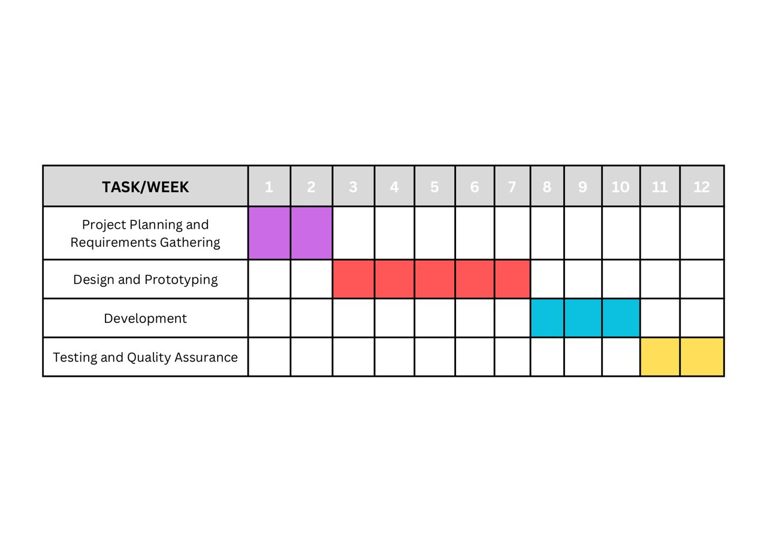

We'll employ a Gantt chart to monitor project milestones and deadlines. Progress reports will be issued every two weeks, outlining completed tasks, upcoming milestones, and any encountered issues. Scheduled meetings with stakeholders will be conducted to review progress and address feedback.

**Risk: -**

* It might be hard to gather data from different social media sites.
* People might not use the dashboard.
* Keeping people's information safe could be a problem.
* Other similar dashboards might be competing with ours.
* To fix these problems, we'll test everything carefully, ask people for their thoughts, and make sure we're following the rules for keeping information safe.

**Conclusion: -**

In conclusion, the Social Media Dashboard offers businesses a comprehensive solution for managing and analyzing social media data. Despite potential risks, our proactive approach to development and user engagement will ensure success. With a clear budget and reporting strategy, we're poised to empower businesses and enhance their online presence effectively.